MACHINE LEARNING · LECTURE NOTES
Ensemble Learning
Bias–Variance Trade-off · Bagging · Random Forests · Boosting (AdaBoost, Gradient Boosting, XGBoost)

Contents
1. The Bias–Variance Trade-off
2. Ensemble Learning: The Big Picture
3. Bagging (Bootstrap Aggregating)
4. Random Forests
5. Boosting: AdaBoost, Gradient Boosting, XGBoost

1. The Bias–Variance Trade-off

1.1 Why models make errors
A trained model's prediction error on new data comes from three sources: bias, variance and irreducible error. Our goal in supervised learning is to build a model that predicts well on unseen data, so we must understand how each source behaves as the model becomes more or less complex.

1.2 Bias
Bias is the difference between the model's average prediction (over many possible training sets) and the true value. It is a systematic error caused by wrong or over-simple assumptions about the data.
- High bias – the model is too simple to capture the real pattern. Result: underfitting; high error on both training and test data.
- Low bias – the model is flexible enough to capture the pattern. Low training error, but if the model is too flexible it also fits noise (see variance).
Example. Fitting a straight line (linear regression) to clearly curved data gives high bias. Linear and logistic regression are typical high-bias models; deep decision trees, k-nearest neighbours with small k, and SVMs with flexible kernels are typical low-bias models.
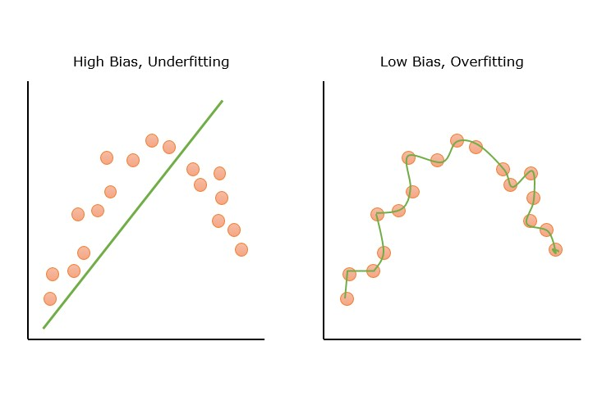
Figure 1. High bias (underfitting) vs. low bias (overfitting) on the same data.

1.3 Variance
Variance measures how much the model's predictions change when the training set changes slightly. A high-variance model reacts to random noise in the training sample as if it were real structure.
- High variance – very complex model; fits the training data (including noise) almost perfectly but does poorly on new data. Result: overfitting; low training error, high test error.
- Low variance – predictions are stable across training sets. Very simple models (or very large training sets) behave this way.
Example. A fully grown (unpruned) decision tree can memorise the training set. Change a few training points and the tree structure changes a lot – that is high variance.
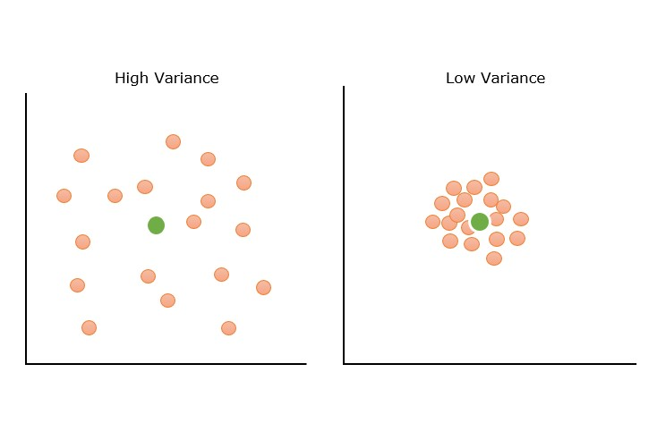
Figure 2. High variance (predictions scattered) vs. low variance (predictions tightly grouped).

1.4 The error decomposition
For squared-error loss, the expected prediction error at a point x decomposes exactly as:
- Bias² – how far the average model is from the truth.
- Variance – how much individual models scatter around that average.
- σ² (irreducible error) – noise in the data itself; no model can remove it.

1.5 The trade-off
As model complexity increases, bias falls but variance rises; as complexity decreases the opposite happens. Total error is U-shaped, and the best model sits near the bottom of the U – the optimal region in Figure 3. Lowering one component usually raises the other, which is why it is called a trade-off.
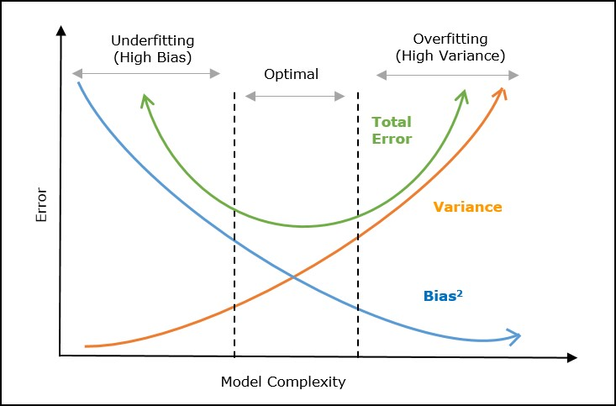
Figure 3. Bias², variance and total error versus model complexity.

1.6 Diagnosing the problem
Situation | Training error | Test error | Diagnosis
Both errors high | High | High | High bias (underfit)
Large gap between errors | Low | High | High variance (overfit)
Both low, small gap | Low | Low | Good fit

1.7 How to reduce each problem
To reduce high bias | To reduce high variance
Use a more complex model | Use a simpler model or prune the tree
Add more (informative) features | Apply regularisation (L1/L2, depth limits)
Reduce regularisation | Collect more training data
Train longer / boost the model | Use cross-validation to detect overfitting early
Ensemble idea: boosting | Ensemble idea: bagging / random forests

1.8 Typical bias and variance of common models
Model | Bias | Variance
Linear / logistic regression | High | Low
Decision stump (depth-1 tree) | High | Low
Fully grown decision tree | Low | High
k-nearest neighbours, small k | Low | High
k-nearest neighbours, large k | Higher | Lower
SVM (flexible kernel, large C) | Low | Higher

This table explains the design of the two ensemble families: deep trees (low bias, high variance) are the ideal inputs for bagging, while stumps (high bias, low variance) are the ideal inputs for boosting.
Key idea for the rest of these notes
Ensembles attack the two error sources differently. Bagging averages many high-variance models to reduce variance. Boosting adds many weak, high-bias models one after another to reduce bias.

2. Ensemble Learning:
An ensemble combines several models (called base learners) so that the combined model performs better, on average, than any individual one. Two broad families are covered in this syllabus:
Family | How models are trained | Main effect | Examples
Bagging | In parallel, on different bootstrap samples; predictions are voted or averaged | Reduces variance | Bagged trees, Random Forest, ExtraTrees
Boosting | Sequentially; each model focuses on the mistakes of the previous ones | Reduces bias (and some variance) | AdaBoost, Gradient Boosting, XGBoost

2.1 Why does voting help?
Suppose each of n classifiers is correct with probability p = 0.7 and their errors are independent. The majority vote is correct whenever more than half of them are correct (a binomial tail probability):
Number of classifiers | Individual accuracy | Majority-vote accuracy
1 | 0.70 | 0.700
3 | 0.70 | 0.784
11 | 0.70 | 0.922
25 | 0.70 | 0.983

Two conditions are essential: each base learner must be better than random guessing (p > 0.5), and the learners must be diverse (their errors must not be strongly correlated). With p = 0.55 and 25 classifiers, accuracy only rises to about 0.69; if all classifiers make the same mistakes, voting gives nothing at all. Every ensemble method below is, at heart, a recipe for creating diverse, reasonably accurate base learners.

2.2 Combining predictions
- Classification: majority (hard) vote, or average of predicted class probabilities (soft vote).
- Regression: simple or weighted average of predictions.
- Boosting uses a weighted vote: better learners get larger weights.

2.3 Other ensemble ideas (for awareness)
- Voting ensembles combine different algorithms (e.g. logistic regression, SVM, tree) by hard or soft vote; bagging instead reuses one algorithm on different data.
- Stacking trains a second-level model (meta-learner) on the predictions of several base models. It is not part of this syllabus' core, but it is the third classic ensemble family.

3. Bagging (Bootstrap Aggregating)
Bagging, introduced by Leo Breiman (1996), trains the same learning algorithm (usually a decision tree) on many different bootstrap samples of the training set and then aggregates the predictions. It works best for unstable learners – models whose predictions change a lot when the training data change slightly, i.e. high-variance models such as unpruned trees.

3.1 Bootstrap sampling
A bootstrap sample of size m is drawn from the m training examples uniformly, with replacement. Some examples appear several times; others do not appear at all.
The probability that a particular example is not chosen in one draw is 1 − 1/m, so after m draws:
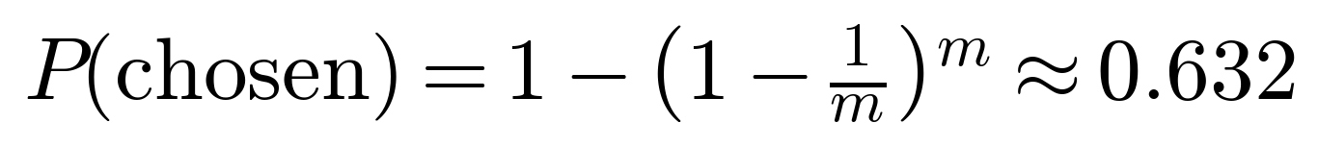
So each bootstrap sample contains only about 63.2 % of the distinct training examples; the remaining ≈ 36.8 % are the out-of-bag (OOB) examples for that tree.
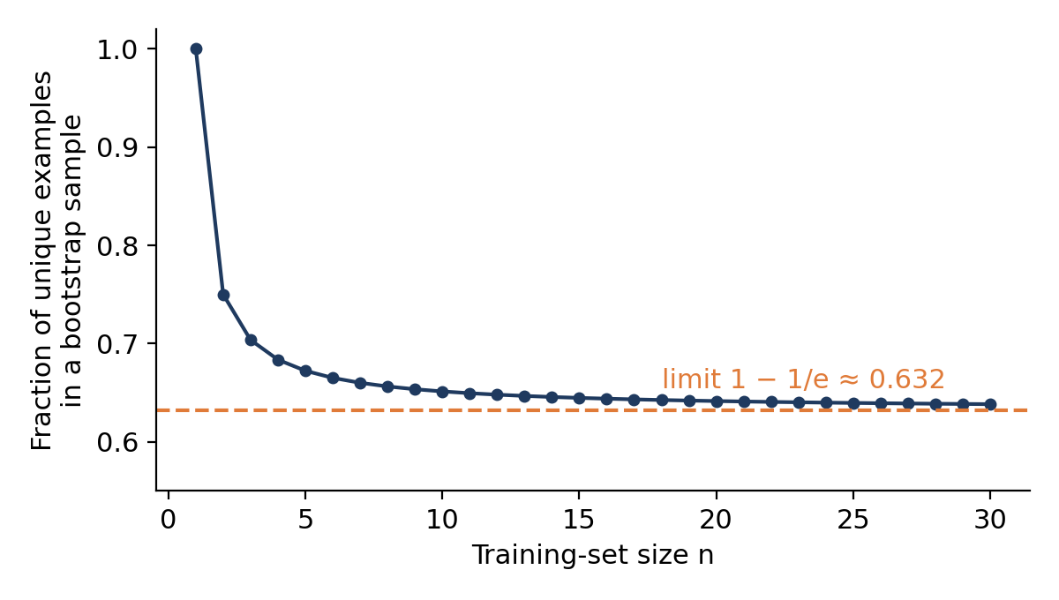
Figure 4. Fraction of unique training examples in a bootstrap sample approaches 0.632.

Worked example
Take a training set of 10 examples numbered 1–10. Three bootstrap samples (drawn with replacement) might look like this:
Round | Bootstrap sample | Distinct examples | Out-of-bag examples
1 | 5, 10, 7, 4, 4, 8, 8, 10, 8, 9 | 6 | 1, 2, 3, 6
2 | 10, 9, 8, 7, 5, 1, 8, 1, 8, 7 | 6 | 2, 3, 4, 6
3 | 4, 6, 9, 9, 8, 6, 1, 1, 3, 9 | 6 | 2, 5, 7, 10

Each sample has the same size as the original data but only 6 distinct examples (close to the expected 63.2 % of 10). Example 2 is out-of-bag in all three rounds, so its OOB prediction would come from the models of rounds 1, 2 and 3 only.

3.2 The algorithm
Algorithm: Bagging
Input: training set D of size m; number of models n.
1. For i = 1 … n: draw a bootstrap sample Dᵢ of size m from D (with replacement).
2. Train a base model hᵢ on Dᵢ.
3. Predict: classification → ŷ = mode{h₁(x), …, hₙ(x)}; regression → ŷ = (1/n) Σ hᵢ(x).

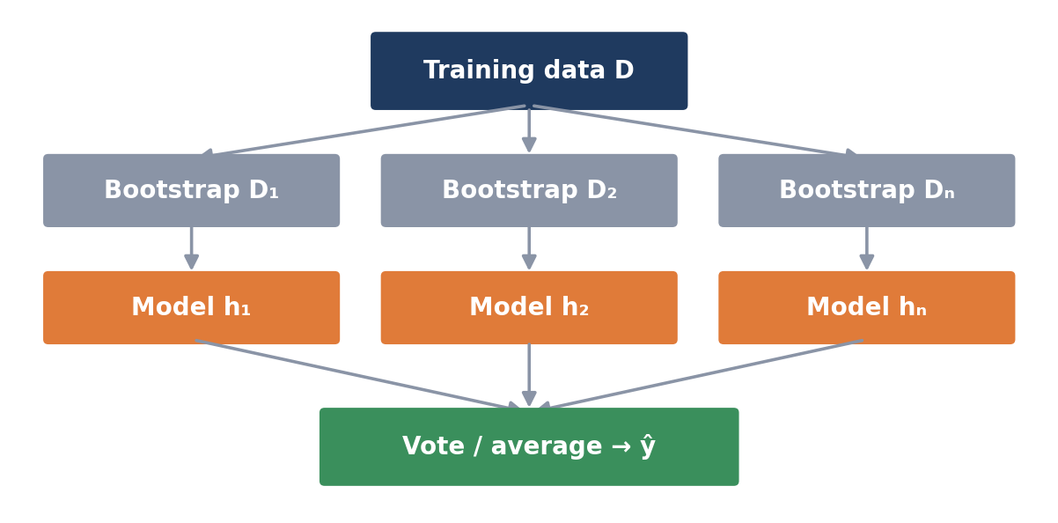
Figure 5. The bagging workflow: bootstrap samples → independent models → vote/average.

3.3 Why bagging reduces variance
If we average B models, each with variance σ² and average pairwise correlation ρ, the variance of the average is:
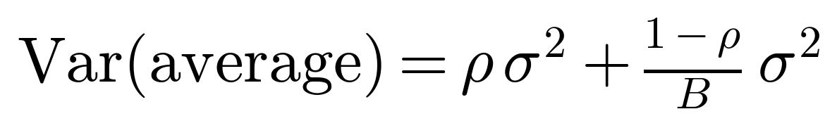
As B grows, the second term vanishes and only ρσ² remains. Two lessons follow: (1) adding more trees never hurts and the benefit levels off; (2) the lower the correlation ρ between trees, the better – the motivation for random forests. Averaging leaves bias almost unchanged, so bagging is useful for low-bias, high-variance base learners.
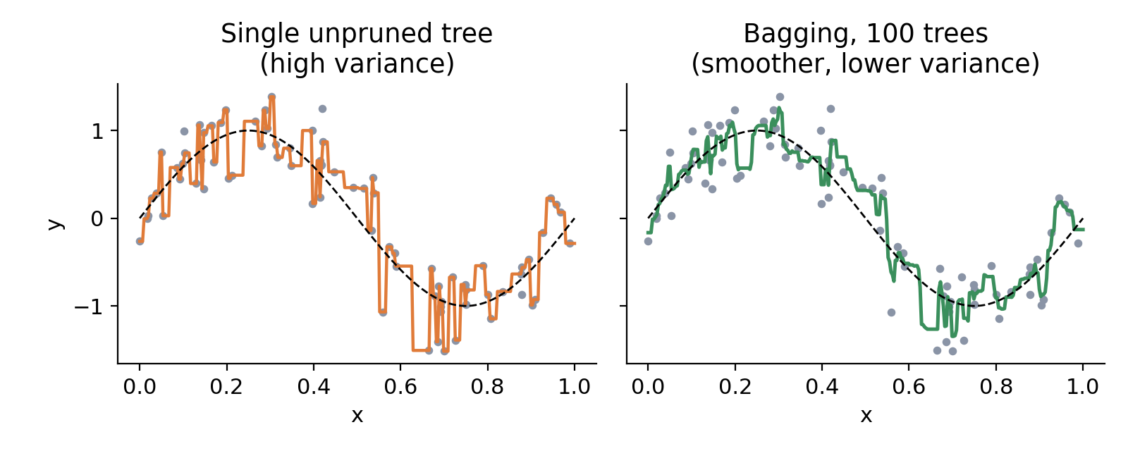
Figure 6. A single unpruned regression tree (left) is jagged; averaging 100 bootstrap trees (right) is much smoother. Dashed line = true function.

3.4 Out-of-bag (OOB) error
Because each tree never sees about a third of the data, we can predict each training example using only the trees for which it was out-of-bag. The resulting OOB error is a nearly free, honest estimate of test error – no separate validation set is needed.

3.5 Advantages and limitations
Advantages | Limitations
Reduces variance and overfitting | Does not reduce bias; useless for very simple (high-bias) learners
Trees can be trained in parallel | Less interpretable than a single tree
OOB error gives built-in validation | Uses more memory/time (n models)
Robust to noisy data and outliers | Trees remain correlated if a few features dominate

4. Random Forests
A random forest is bagging with decision trees plus one extra source of randomness: at every split, only a random subset of the features is considered. This decorrelates the trees (smaller ρ in the variance formula above), so averaging them reduces variance even more than plain bagging. Random forests are among the most widely used algorithms because they perform well "out of the box" with little tuning.

4.1 The algorithm
Algorithm: Random Forest
For b = 1 … B:
1. Draw a bootstrap sample of the training data.
2. Grow a decision tree on it. At each node, choose a random subset of features out of the m available, and pick the best split among only those.
3. Grow the tree deep (little or no pruning).
Predict: majority vote (classification) or average (regression) over the B trees.

Choosing the subset size. The number of features per split is a tunable hyperparameter. Common defaults are about √m for classification and m/3 for regression; Breiman also suggested log₂(m) + 1 as a rule of thumb. Smaller subsets give more diverse (less correlated) but individually weaker trees.

4.2 Per tree or per node? (Ho vs. Breiman)
- Tin Kam Ho (1995) – the random subspace method: each tree receives one random subset of features and uses only those throughout.
- Leo Breiman (2001) – each node of each tree draws a fresh random subset of features, while the tree has access to all features overall. This is the version we mean today by "random forest".

4.3 Why it works: strength and correlation
Breiman showed that the generalisation error of a forest is bounded by:
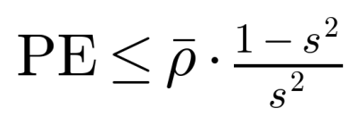
where ρ̄ is the average correlation between trees and s is the strength of the individual trees (their average margin). Lower correlation → lower error; higher strength → lower error. Random feature selection slightly lowers each tree's strength but lowers the correlation by more, so the net result is typically better than plain bagging.

4.4 OOB error and feature importance
- OOB error works exactly as in bagging and gives a built-in estimate of test error.
- Feature importance – although a forest is less interpretable than one tree, we can measure how much each feature reduces impurity (or how much accuracy drops when the feature's values are shuffled). This is covered further in the Feature Selection topic.

4.5 Extremely Randomised Trees (ExtraTrees) – for awareness
ExtraTrees go one step further: at each node the split threshold is also chosen at random (for each candidate feature), and the best of these random splits is used. No search for the optimal threshold is needed, so training is faster, and the extra randomness further decorrelates the trees – at the cost of weaker individual trees.

4.6 Key hyperparameters
Hyperparameter | Meaning | Effect of increasing it
Number of trees (B) | Number of trees | Lower variance; more compute; plateaus
Features tried per split (m_try) | Number of random features considered at each split | Higher correlation and strength
Tree depth / minimum leaf size | Tree size limits | Lower variance, higher bias
OOB estimate | Use out-of-bag examples to validate | —

5. Boosting
Boosting converts weak learners (models only slightly better than random guessing, e.g. decision stumps – trees with one split) into a strong learner. Unlike bagging, learners are trained sequentially: each new learner concentrates on the examples the earlier ones got wrong. The final prediction is a weighted vote.
General boosting recipe
1. Start with equal weights on all training examples.
2. Train a weak learner on the (re)weighted data.
3. Increase the weight of the examples it misclassified (or fit the remaining errors).
4. Repeat for many rounds, then combine all learners with a weighted vote: H(x) = sign( Σⱼ αⱼ hⱼ(x) ).

The two main families differ in how the weights/targets are updated and how learners are combined: adaptive boosting (AdaBoost) reweights examples; gradient boosting (including XGBoost) fits each new learner to the gradient of the loss.

5.1 AdaBoost (Adaptive Boosting)
AdaBoost was proposed by Freund and Schapire (1997). Labels are y ∈ {−1, +1}.
Algorithm: AdaBoost
1. Initialise weights wᵢ = 1/N for i = 1 … N.
2. For t = 1 … T:
(a) Train weak learner hₜ on the training data using weights w.
(b) Weighted error: εₜ = Σ wᵢ · 1[hₜ(xᵢ) ≠ yᵢ] (if εₜ ≥ 0.5, stop).
(c) Learner weight: αₜ = ½ ln((1 − εₜ) / εₜ).
(d) Update: wᵢ ← wᵢ · exp(−αₜ yᵢ hₜ(xᵢ)), then normalise so Σ wᵢ = 1.
3. Final classifier: H(x) = sign( Σₜ αₜ hₜ(x) ).

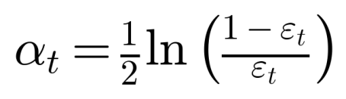
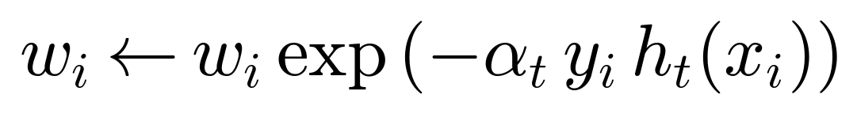
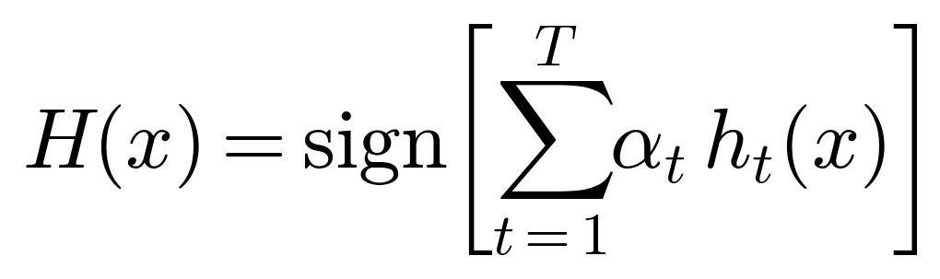
Reading the formulas. αₜ is large when the error εₜ is small, so accurate learners get a louder vote. In step (d), a misclassified example has yᵢhₜ(xᵢ) = −1, so its weight is multiplied by exp(+αₜ), which is greater than 1; a correctly classified one is multiplied by exp(−αₜ), which is less than 1.

Worked example (one round)
Ten training examples start with weight 0.1 each. The first stump misclassifies 3 of them.
Quantity | Value
Weighted error ε₁ | 3 × 0.1 = 0.30
Learner weight α₁ | ½ ln(0.70 / 0.30) = 0.4236
Misclassified: unnormalised weight | 0.1 × exp(0.4236) = 0.1528
Correct: unnormalised weight | 0.1 × exp(−0.4236) = 0.0655
Sum of unnormalised weights | 3(0.1528) + 7(0.0655) = 0.9165
New normalised weights | Misclassified: 0.1667 each (total 0.50); correct: 0.0714 each (total 0.50)

After the update the 3 hard examples carry half of the total weight, so the next stump is forced to concentrate on them. Figure 7 shows three rounds on a toy dataset – marker size is proportional to the example's weight.
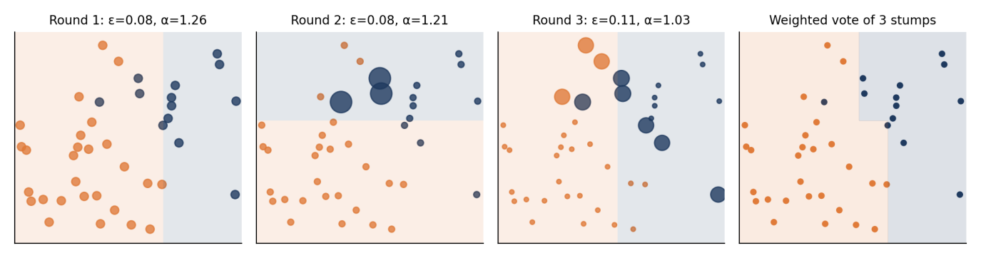
Figure 7. AdaBoost on a toy dataset: three weighted stumps (left three panels) and their weighted vote (right).

Properties of AdaBoost
- Typically uses stumps or shallow trees; each is a high-bias, low-variance learner, so boosting mainly reduces bias.
- Often resists overfitting for many rounds, but is sensitive to noisy labels and outliers, because misclassified noisy points keep gaining weight.
- Number of rounds T and the learning rate are the key hyperparameters; use cross-validation to choose them.
AdaBoost: advantages | AdaBoost: limitations
Simple; few hyperparameters | Sensitive to noisy labels and outliers
Often high accuracy with stumps | Sequential, so cannot be parallelised across rounds
Automatic focus on hard examples | Needs weak learners that beat 50 % accuracy

5.2 Gradient Boosting
Gradient boosting (Friedman, 2001) treats boosting as gradient descent in function space. We build an additive model F(x) = F₀ + ν Σ hₘ(x), where each new tree hₘ is fitted to the negative gradient of the loss with respect to the current predictions (called pseudo-residuals).
Algorithm: Gradient Boosting
1. Initialise with a constant: F₀(x) = arg min_c Σ L(yᵢ, c) (the mean of y for squared error).
2. For m = 1 … M:
(a) Compute pseudo-residuals: rᵢ = − ∂L(yᵢ, F(xᵢ)) / ∂F(xᵢ) evaluated at F = Fₘ₋₁.
(b) Fit a small regression tree hₘ to the targets rᵢ.
(c) Update: Fₘ(x) = Fₘ₋₁(x) + ν · hₘ(x), with learning rate (shrinkage) 0 < ν ≤ 1.
3. Output F_M(x).

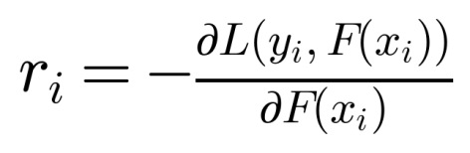
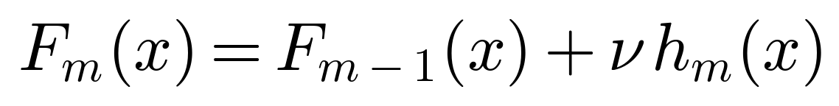
Special case – squared error. For L = ½(y − F)² the negative gradient is simply y − F, i.e. the ordinary residual. So each tree is fitted to what the model currently gets wrong, and adding it shrinks the residual. For classification we use the log-loss and the residuals become (y − predicted probability).
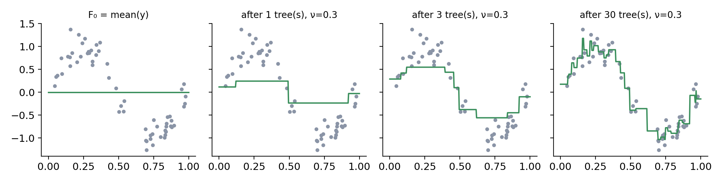
Figure 8. Gradient boosting for regression: starting from the mean, each depth-2 tree is fitted to the current residuals and added with learning rate ν = 0.3.
- Learning rate ν: small values need more trees but generalise better. A standard trade-off is small ν + large M.
- Tree depth: shallow trees (depth 3–6) capture interactions without high variance.
- Subsampling (stochastic gradient boosting): fit each tree on a random fraction of the rows to add randomness and reduce variance.

5.3 XGBoost (Extreme Gradient Boosting)
XGBoost (Chen & Guestrin, 2016) is a highly optimised, regularised implementation of gradient boosted trees. It became popular because it is fast, accurate and handles real-world data issues. What it adds to the basic algorithm falls into two groups.

A. Algorithmic improvements
Regularised objective. At round t, XGBoost minimises
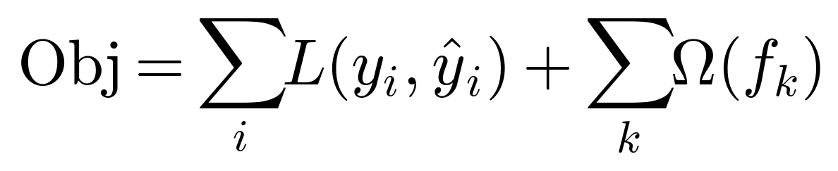
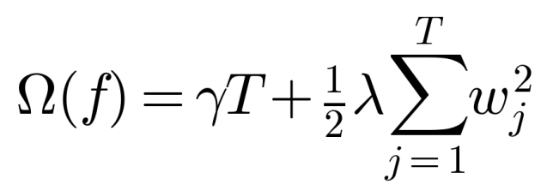
where T is the number of leaves of the tree and wⱼ are the leaf scores. γ penalises extra leaves and λ shrinks leaf scores (L2). This controls model complexity directly, which plain gradient boosting does not.
Second-order approximation. The loss is expanded to second order around the current prediction using the gradient gᵢ and the Hessian hᵢ of the loss for each example. For a leaf containing the set of examples I, with G = Σ gᵢ and H = Σ hᵢ:
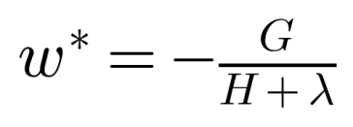
Split gain. To decide whether to split a node into left (L) and right (R) children, XGBoost computes:
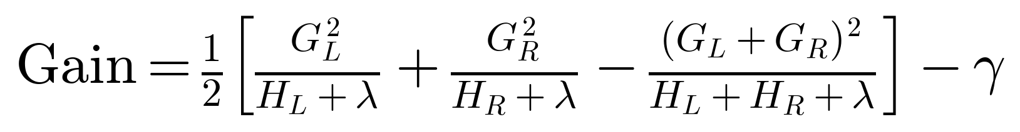
A split is made only if the gain is positive, so γ acts as a built-in pruning threshold. Using Hessians as well as gradients gives better-informed steps (similar in spirit to Newton's method).

B. Practical / engineering features
- Sparsity-aware split finding – learns a default direction for missing values, so missing data are handled natively.
- Shrinkage and column subsampling (as in random forests) to reduce overfitting.
- Efficient split search – pre-sorted/histogram-based approximate splits (weighted quantile sketch) for large data.
- Parallel, cache-aware computation and out-of-core learning; GPU support.
- Built-in cross-validation and early stopping on a validation set.

Key XGBoost hyperparameters
Parameter | Role | Typical guidance
Number of rounds (T) | Number of boosting rounds | Large, with early stopping
Learning rate (η) | Shrinkage on each tree | 0.01–0.3; smaller = safer, needs more trees
Maximum tree depth | Tree depth | 3–8; deeper = higher variance
Row and column subsampling | Row / column sampling | 0.5–1.0; <1 reduces overfitting
Regularisation λ and γ | L2 penalty; minimum gain to split | Increase to regularise more
Minimum child weight | Minimum Hessian sum in a leaf | Increase to avoid tiny leaves

XGBoost vs. standard gradient boosting
Aspect | Standard gradient boosting | XGBoost
Loss approximation | First order (gradient only) | Second order (gradient and Hessian)
Regularisation | Only shrinkage / depth limits | Explicit penalties γ and λ in the objective
Missing values | Must be imputed | Learned default direction per split
Pruning | Stops by depth | Grows then prunes using gain − γ
Speed | Single-threaded, exact splits | Parallel, histogram / approximate splits

XGBoost: advantages | XGBoost: limitations
State-of-the-art accuracy on tabular data | Many hyperparameters to tune
Fast and scalable; handles missing data | Less interpretable than a single tree
Built-in regularisation and early stopping | Can still overfit small or noisy data

6. Comparison and Choosing a Method

6.1 Bagging vs. boosting
Aspect | Bagging / Random Forest | Boosting (AdaBoost, GB, XGBoost)
Training | Parallel, independent models | Sequential; each depends on the previous
Base learner | Strong, high-variance (deep trees) | Weak, high-bias (stumps, shallow trees)
Data per model | Bootstrap sample | Reweighted data / residuals
Main effect | Reduces variance | Reduces bias (and some variance)
Combination | Equal vote / average | Weighted sum
Noise sensitivity | Robust | Can overfit noisy data
Tuning effort | Low | Higher (learning rate, depth, rounds)
Typical accuracy | Very good | Often the best on tabular data when tuned

6.2 Method-by-method summary
Method | Core idea | Key formula / feature | Watch out for
Bagging | Average models on bootstrap samples | 63.2 % unique per sample; OOB error | No bias reduction
Random Forest | Bagging + random feature subset per node | PE ≤ ρ̄(1 − s²)/s² | Large forests can be slow
AdaBoost | Reweight misclassified examples | α = ½ ln((1 − ε)/ε) | Noisy labels, outliers
Gradient Boosting | Fit residuals (negative gradient) | F ← F + ν·h | Needs tuning; sequential
XGBoost | Regularised, 2nd-order gradient boosting | w* = −G/(H+λ); gain with γ | Many hyperparameters

